**Monday**

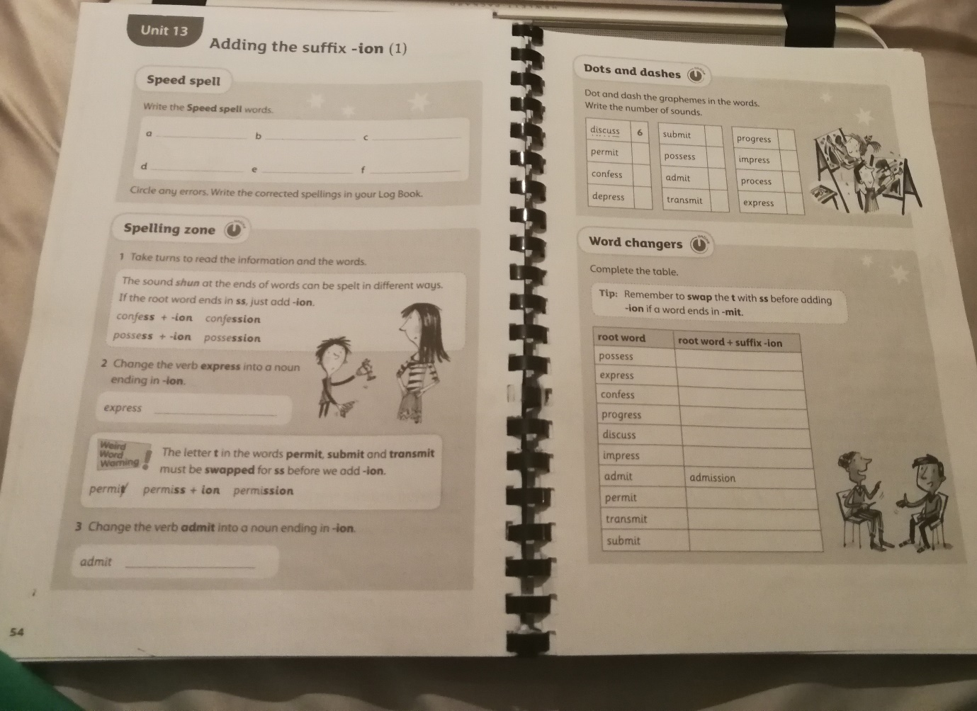

**Tuesday**

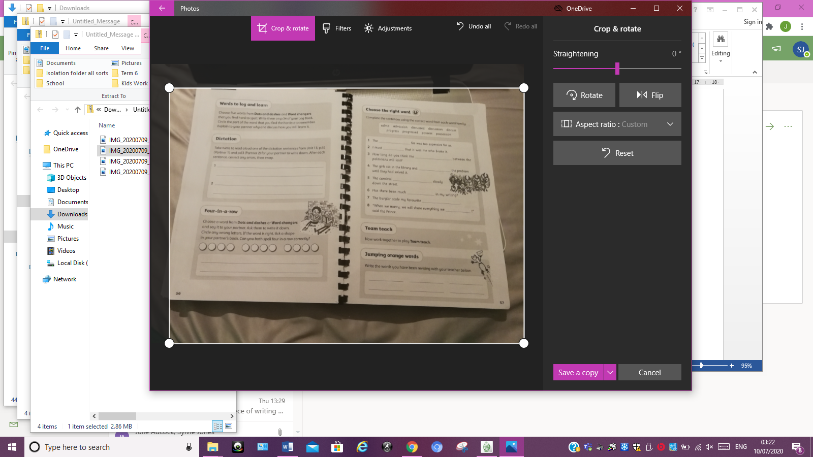

**Wednesday**

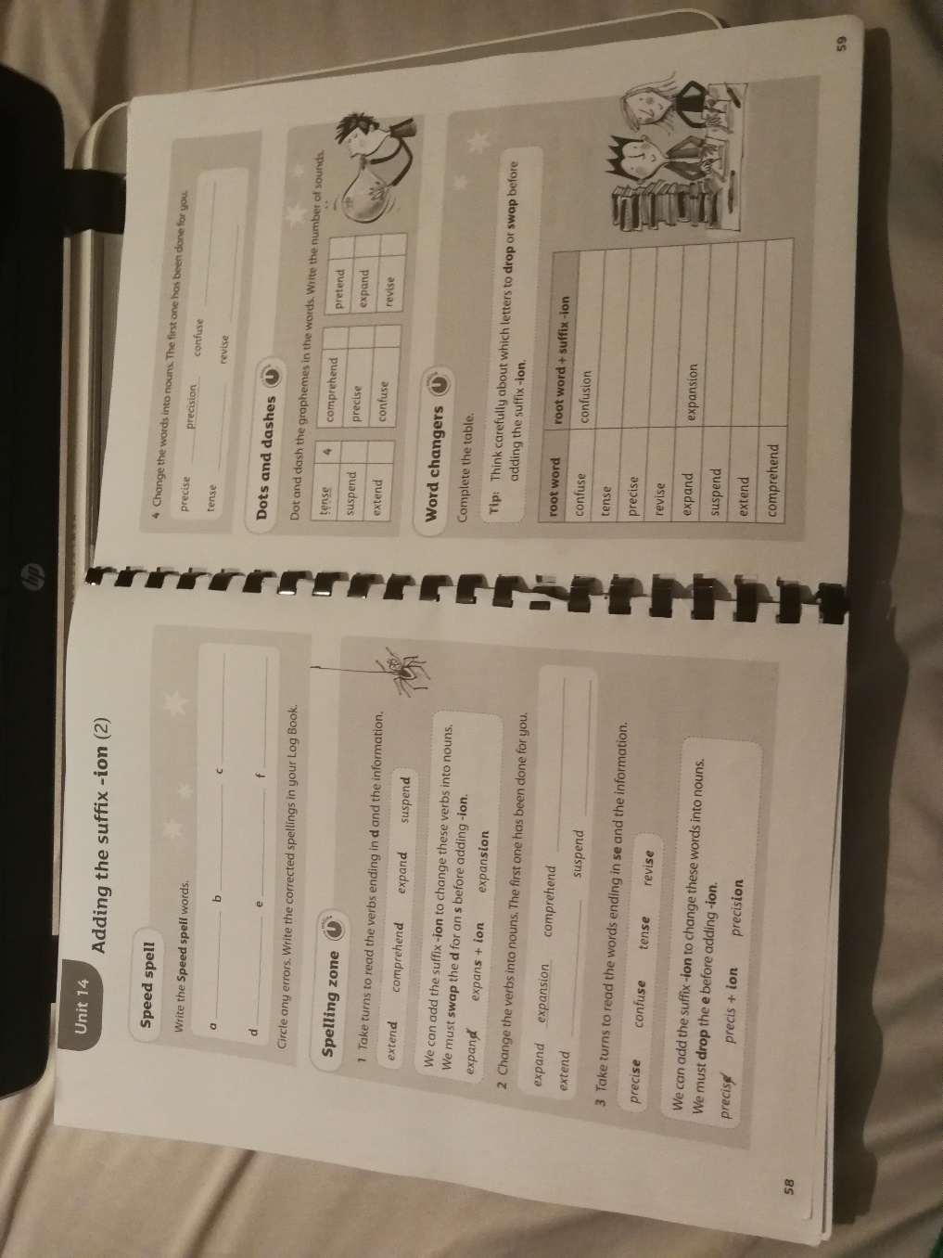

**Thursday**

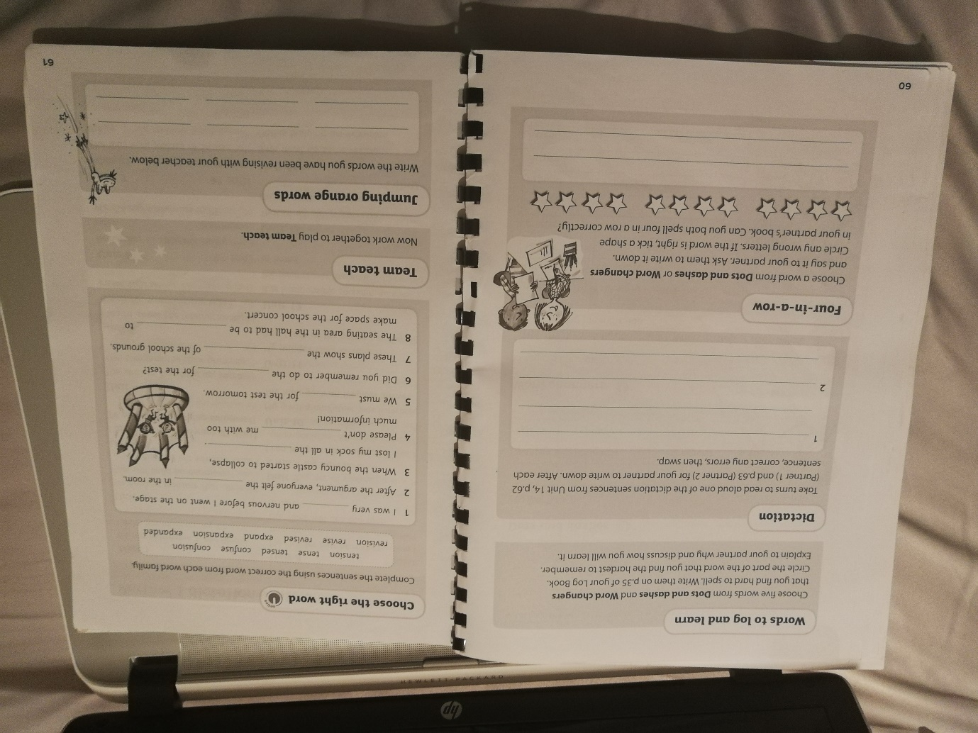

**Friday -** practise them all and other spellings found in your spelling log book.