Vocabulary

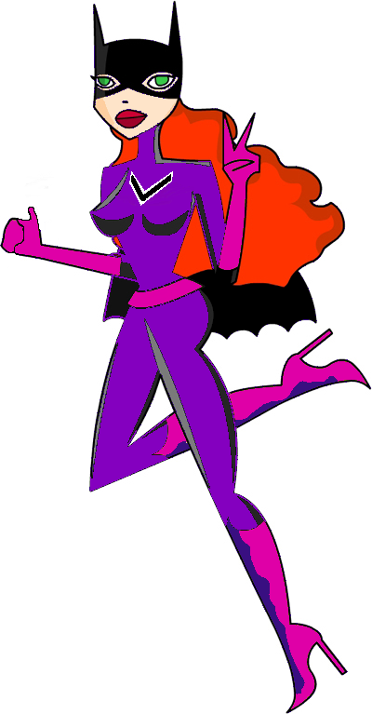

Victoria Visualiser

Victoria’s Super Powers

Victoria has the power to help people really see how things look.
She holds the secret of how characters and places really feel.
Although, words for sights and sounds are her favourite weapons she knows the importance of taste, touch and smell too.

Victoria knows how to pick just the right nouns or verbs to give writing real power over a reader.
She uses adjectives and adverbs to hypnotise people in to really seeing and feeling a piece of writing.

Connectives

Captain Connective

The Captain’s Super Powers.

The Captain holds the team together and without him writing can be repetitive and boring holding no power over the reader at all.

His greatest power is to link ideas together providing a net to catch any reader.

Openers

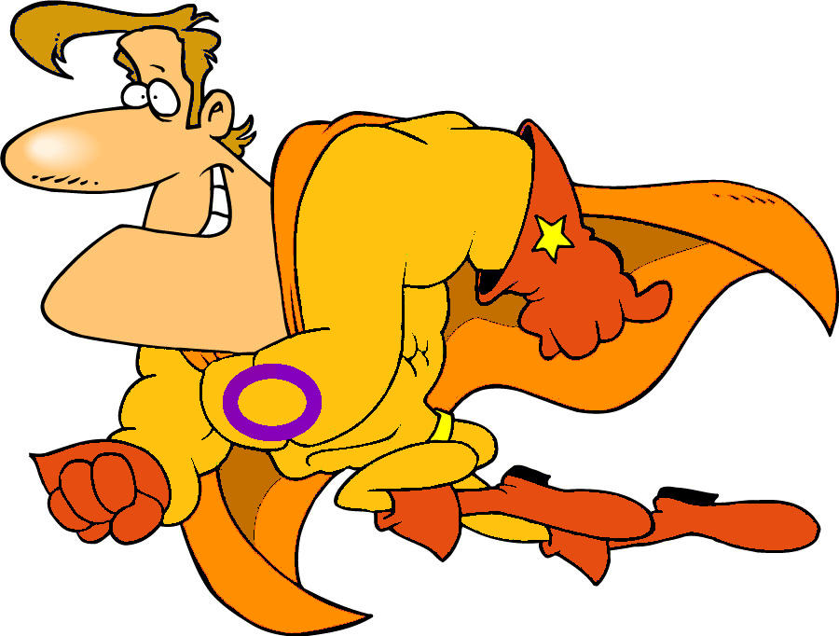

The Incredible Opener

The Incredible Opener’s Super Powers.

The Incredible Opener is a master of disguise.
Sometimes, he jumps up and tells the reader when something is happening. Suddenly, he is adverb. Although, can be a link between ideas just like Captain Connective. Alternatively, he can express an opposite idea. On dark, windy nights, when even the wolves stay in their dens, he can be a whole phrase!

He may seem like a bit of a Joker, but don’t be fooled he helps add structure. It’s his job to hook the reader in and keep him reading.

Punctuation

Doctor
Punctuation

Dr Punctuation’s Super Powers

The Doctors basic weapon is the power to stop and start a sentence. If capital letters and full stops are missing, or in the wrong place writing, is weak. It will not have the power to grab a reader.

His control over the reader is reinforced by the use of commas to separate ideas. They work well when combined with connectives and openers.

He reveals what characters actually say with speech marks.

Does he ask questions? Of course, that’s a great weapon for hooking a reader.

He does not use his best weapons too often or their effects weaken. But, wow! An exclamation mark makes a reader think.
An ellipsis makes a reader wonder…

VCOP
Super Heros

Here to help you
trap your reader.

